**INVENTORY MANAGEMENT SYSTEM**

SUBMITTED BY:

* SADIA KHAN (233544)
* DANISH BUTT (233606)
* SOMAL ATTA (233530)

SUBMITTED TO: MAAM AATKA

BSCS(B) 3rd

AIR UNIVERSITY MULTAN CAMPUS

Contents

[Abstract 4](#_Toc186935232)

[Introduction 5](#_Toc186935233)

[**Objectives** 5](#_Toc186935234)

[**Core Features of IMS** 6](#_Toc186935235)

[1. Inventory Tracking 6](#_Toc186935236)

[• Real-Time Stock Updates: 6](#_Toc186935237)

[• Multi-location Support: 6](#_Toc186935238)

[• Batch and Serial Tracking 6](#_Toc186935239)

[• Stock Movement History 6](#_Toc186935240)

[2. Product Management 6](#_Toc186935241)

[• Product Registration: 6](#_Toc186935242)

[• Barcode Integration 6](#_Toc186935243)

[• Categorization: 6](#_Toc186935244)

[• Unit of Measure Support: 6](#_Toc186935245)

[3. Order Management 6](#_Toc186935246)

[• Purchase Order Management: 6](#_Toc186935247)

[• Sales Order Management: 6](#_Toc186935248)

[• Reorder Point Alerts: 6](#_Toc186935249)

[• Supplier and Vendor Management: 6](#_Toc186935250)

[4. Stock Control 7](#_Toc186935251)

[• Stock In/Out Transactions: 7](#_Toc186935252)

[• Stock Transfers 7](#_Toc186935253)

[• Stock Adjustment: 7](#_Toc186935254)

[5. Reporting and Analytics 7](#_Toc186935255)

[• Inventory Valuation: 7](#_Toc186935256)

[• Stock Movement Reports 7](#_Toc186935257)

[• Sales and Purchase Reports: 7](#_Toc186935258)

[• Demand Forecasting: 7](#_Toc186935259)

[6. User Management 7](#_Toc186935260)

[• Role-Based Access Control: 7](#_Toc186935261)

[• User Authentication: 7](#_Toc186935262)

[• Audit Logs: 7](#_Toc186935263)

[7. Integration and Automation 7](#_Toc186935264)

[• Accounting Integration: 7](#_Toc186935265)

[• E-commerce Integration: 7](#_Toc186935266)

[• Email and Notifications 7](#_Toc186935267)

[8. Security and Compliance 7](#_Toc186935268)

[• Data Encryption: 7](#_Toc186935269)

[• Backup and Recovery: 7](#_Toc186935270)

[• Compliance Support: 8](#_Toc186935271)

[Database Design 8](#_Toc186935272)

[Products Table: 8](#_Toc186935273)

[Suppliers Table: 8](#_Toc186935274)

[PurchaseOrders Table: 8](#_Toc186935275)

[SalesOrders Table: 9](#_Toc186935276)

[StockMovements Table: 9](#_Toc186935277)

[Users Table: 9](#_Toc186935278)

[AuditLogs Table: 9](#_Toc186935279)

[Categories Table: 9](#_Toc186935280)

[User Interface Components 9](#_Toc186935281)

[Dashboard 9](#_Toc186935282)

[Product Management 9](#_Toc186935283)

[Inventory Tracking 10](#_Toc186935284)

[Purchase and Sales Order Management 10](#_Toc186935285)

[Reports and Analytics 10](#_Toc186935286)

[Functionalities 10](#_Toc186935287)

[Login and Registration 10](#_Toc186935288)

[Dashboard 10](#_Toc186935289)

[Product Management 10](#_Toc186935290)

[Order Processing 10](#_Toc186935291)

[Inventory Movements 10](#_Toc186935292)

[Reporting 10](#_Toc186935293)

[Business Logic 11](#_Toc186935294)

[Description of Core Logic 11](#_Toc186935295)

[Problem-Solving Approach 11](#_Toc186935296)

[**Flowchart** 11](#_Toc186935297)

[**Case Diagram :** 12](#_Toc186935298)

[**Sequence Diagram** 13](#_Toc186935299)

[**Activity Diagram** 14](#_Toc186935300)

[**Class Diagram** 15](#_Toc186935301)

[Overview of Class Structure 15](#_Toc186935302)

[Class Relationships 15](#_Toc186935303)

[Associations and Inheritance 16](#_Toc186935304)

[Implementation 16](#_Toc186935305)

[Development Process 16](#_Toc186935306)

[Screenshots of all User Interfaces 17](#_Toc186935307)

[Tools and Technologies Used 26](#_Toc186935308)

[Challenges and Solutions 26](#_Toc186935309)

[Enhanced Theme and User Interface Design 27](#_Toc186935310)

[Login and Registration Features 27](#_Toc186935311)

[Scroll Bar Integration 27](#_Toc186935312)

[Dashboard: 27](#_Toc186935313)

[Grid View: 27](#_Toc186935314)

[Side Panel: 27](#_Toc186935315)

[Icon Integration 27](#_Toc186935316)

[Explanation 28](#_Toc186935317)

[**Conclusion** 28](#_Toc186935318)

[References 28](#_Toc186935319)

[Books 28](#_Toc186935320)

[Web References 29](#_Toc186935321)

# Abstract

The Inventory Management System (IMS) is a comprehensive and innovative solution crafted to enhance inventory tracking, product management, and order processing for businesses of all scales, from small enterprises to large corporations. With its intuitive user interface, seamless integration capabilities, and robust set of features, IMS addresses the complexities of modern inventory management and serves as an essential tool for streamlining operations.

This report provides an extensive analysis of the IMS, focusing on its core features, such as real-time inventory updates, multi-location tracking, and batch management. It also delves into the system’s database design, which ensures data integrity and facilitates smooth operations, and user interface components designed for maximum usability and aesthetic appeal. The IMS empowers businesses to reduce operational inefficiencies, minimize wastage, and enhance decision-making through insightful reporting and demand forecasting.

Security, scalability, and compliance with industry standards are fundamental to the system's architecture, ensuring that it can adapt to growing business needs while safeguarding sensitive data. The IMS also supports seamless integration with external systems, such as e-commerce platforms and accounting tools, further enhancing its utility.

By combining advanced functionalities with a focus on user experience, the IMS stands out as a reliable and efficient solution, enabling businesses to maintain competitive advantage and meet the demands of a dynamic market. Through its well-rounded capabilities and forward-thinking design, IMS offers not just a system but a strategy for sustainable and scalable inventory management.

# Introduction

The Inventory Management System (IMS) is a sophisticated software solution designed to streamline inventory tracking, product management, and order processing for businesses of all sizes. By integrating advanced features such as real-time stock updates, multi-location support, and batch tracking, the IMS provides organizations with a robust platform to enhance operational efficiency and improve customer satisfaction. In today's fast-paced and competitive market, businesses face significant challenges in managing their inventory effectively. Traditional inventory management techniques often fall short, leading to issues such as stockouts, overstocking, and inefficient order processing. These challenges can result in lost sales, increased operational costs, and diminished customer satisfaction. The IMS addresses these issues by offering a comprehensive solution that ensures accurate inventory management and facilitates informed decision-making. Effective inventory management is crucial for maintaining optimal stock levels, minimizing losses, and enhancing customer satisfaction. The inability to manage inventory efficiently can lead to financial losses and a negative impact on a company's reputation. The IMS is significant as it provides businesses with the tools necessary to overcome these challenges, ensuring they remain competitive in a dynamic market.

# **Objectives**

The primary goals of the IMS include:

* Providing real-time updates on stock levels and movements.
* Enabling multi-location inventory tracking and batch or serial tracking for improved traceability.
* Facilitating the registration, categorization, and management of products with barcode integration.
* Supporting multiple units of measurement for flexible inventory handling.
* Managing purchase and sales orders while linking them with inventory updates.

The expected outcomes of implementing the IMS are:

* Enhanced accuracy in inventory management.
* Improved operational efficiency through streamlined processes.
* Increased customer satisfaction due to timely order fulfillment.
* Comprehensive reporting and analytics for informed decision-making.
* Secure user operations through role-based access control and audit logging.

# **Core Features of IMS**

## 1. Inventory Tracking

* Real-Time Stock Updates: Automatically updates stock levels during sales, purchases, or adjustments.
* Multi-location Support: Tracks inventory across multiple warehouses or store locations.
* Batch and Serial Tracking: Manages products by batch, lot, or unique serial numbers for traceability.
* Stock Movement History: Maintains a log of all stock movements (inflows, outflows, adjustments).

## 2. Product Management

* Product Registration: Add, update, or remove products with details such as SKU, category, and price.
* Barcode Integration: Generates and scans barcodes for quick product identification.
* Categorization: Organizes products into categories or groups for easier management.
* Unit of Measure Support: Manages inventory with various units (e.g., boxes, pieces, kg).

## 3. Order Management

* Purchase Order Management: Creates, tracks, and manages purchase orders from suppliers.
* Sales Order Management: Processes customer sales orders and links them to inventory.
* Reorder Point Alerts: Sends alerts when stock levels drop below a defined threshold.
* Supplier and Vendor Management: Maintains supplier details and purchase history.

## 4. Stock Control

* Stock In/Out Transactions: Records inventory inflows (purchases) and outflows (sales).
* Stock Transfers: Moves stock between different locations or warehouses.
* Stock Adjustment: Adjusts stock levels due to shrinkage, damage, or other factors.

## 5. Reporting and Analytics

* Inventory Valuation: Generates real-time reports on the total value of inventory.
* Stock Movement Reports: Tracks historical data on stock inflows, outflows, and adjustments.
* Sales and Purchase Reports: Analyzes sales trends, purchase history, and supplier performance.
* Demand Forecasting: Predicts future inventory needs based on historical data.

## 6. User Management

* Role-Based Access Control: Defines user roles (Admin, Manager, Staff) with specific permissions.
* User Authentication: Secures login with password encryption.
* Audit Logs: Tracks and logs user actions for accountability.

## 7. Integration and Automation

* Accounting Integration: Syncs inventory data with accounting systems like QuickBooks or Xero.
* E-commerce Integration: Integrates with platforms like Shopify or WooCommerce for real-time updates.
* Email and Notifications: Sends alerts and updates via email or in-app notifications.

## 8. Security and Compliance

* Data Encryption: Protects sensitive data with encryption during storage and transmission.
* Backup and Recovery: Implements automated backups and disaster recovery plans.
* Compliance Support: Ensures compliance with industry regulations (e.g., GDPR, ISO).

The IMS incorporates innovative aspects such as:

* A user-friendly interface designed for intuitive navigation.
* Real-time data synchronization with external systems.
* Advanced reporting tools that leverage historical data for predictive analytics.
* Customizable alerts and notifications to keep users informed of critical inventory levels.

# Database Design

The database design for IMS is structured to support efficient inventory management and order processing. Below is a detailed explanation of the key tables:

# Products Table:

* + Stores information about all products, including their unique identifiers, names, categories, and stock levels.
  + Tracks additional attributes such as SKU, unit price, and barcode for better identification and management.
  + Includes timestamps to record when products are added or updated.

# Suppliers Table:

* + Maintains details about suppliers, such as their names, contact information, and addresses.
  + Links with purchase orders to streamline supplier management and history tracking.

# Purchase-Orders Table:

* + Records purchase orders made to suppliers, including order dates, statuses, and total amounts.
  + Links to the Suppliers table to identify the associated supplier for each order.

# Sales-Orders Table:

* + Tracks customer sales orders, including customer names, order statuses, and total amounts.
  + Links with products to associate items with specific orders.

# Stock-Movements Table:

* + Logs all stock inflows, outflows, and adjustments, providing a detailed history of inventory changes.
  + Categorizes movements by type (e.g., IN, OUT, ADJUSTMENT) and records quantities and descriptions.

# Users Table:

* + Manages user accounts, including usernames, hashed passwords, and roles (Admin, Manager, Staff).
  + Includes timestamps to track when users are created.

# Audit-Logs Table:

* + Maintains a record of user actions within the system for accountability.
  + Logs include the action performed, affected modules, and timestamps.

# Categories Table:

* + Stores product categories to allow for easy organization and filtering.
  + Includes unique identifiers and descriptions for each category.

# User Interface Components

## Dashboard

* Central overview displaying key metrics and summaries.
* **Features**: Real-time stock levels, low stock alerts, sales and purchase summaries.

## Product Management

* Interface for adding, editing, and deleting product information.
* **Features**: Product details, barcode generation, category selection.

## Inventory Tracking

* Displays detailed stock information for each product.
* **Features**: Stock levels by location, batch/serial tracking, recent stock movements.

## Purchase and Sales Order Management

* Modules to create and manage orders.
* **Features**: Supplier selection, customer details, order status tracking.

## Reports and Analytics

* Generates reports and visualizes data for better decision-making.
* **Features**: Inventory valuation, sales trends, stock movement analytics.

# Functionalities

## Login and Registration

* Secure login page for users with role-based access.
* Registration feature for adding new users with appropriate roles.

## Dashboard

* Provides a summary of inventory levels, recent activities, and alerts.

## Product Management

* Add, edit, and delete products with SKU, barcode, and category options.

## Order Processing

* Create purchase and sales orders with detailed line items.
* Track order statuses and update inventory accordingly.

## Inventory Movements

* Record stock inflows, outflows, and adjustments.
* Support for multi-location stock transfers.

## Reporting

* Generate real-time reports on stock valuation, sales trends, and demand forecasting.

# Business Logic

## Description of Core Logic

The core logic of the IMS revolves around maintaining accurate inventory records, processing orders efficiently, and providing users with actionable insights through reporting. The system utilizes a relational database to store product, order, and user information, ensuring data integrity and accessibility.

## Problem-Solving Approach

The IMS employs a systematic approach to problem-solving by:

* Identifying key pain points in inventory management.
* Implementing features that address these pain points directly.
* Continuously gathering user feedback to refine and enhance system functionalities.

# **Flowchart**

**Application Flow Representation**

It represents general software development lifecycle:

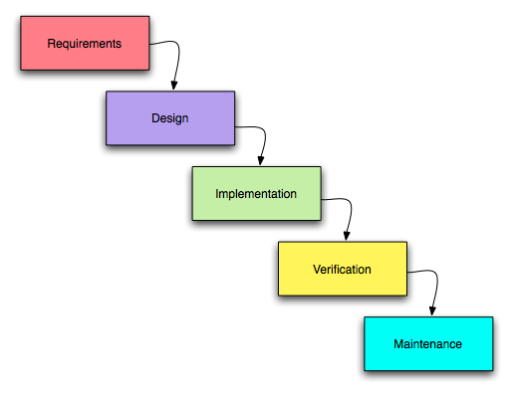

## **Case Diagram:**

C:\Documents and Settings\SHARMA\Desktop\use_case_diagram.jpg

C:\Documents and Settings\SHARMA\Desktop\dsgn_usepkgs.jpg

Administrator

Client / User

## **Sequence Diagram**

Admin Side:

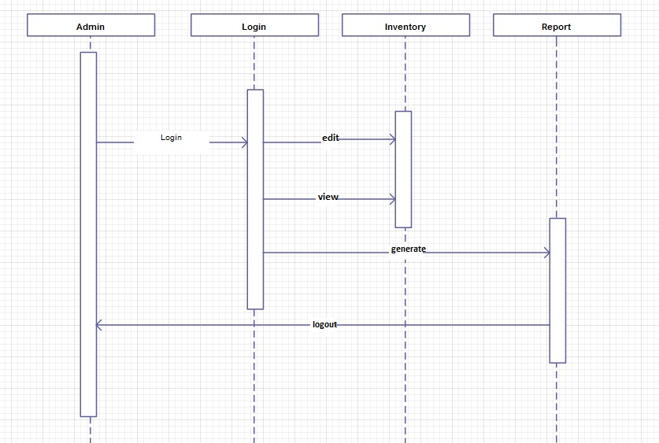

Client Side:

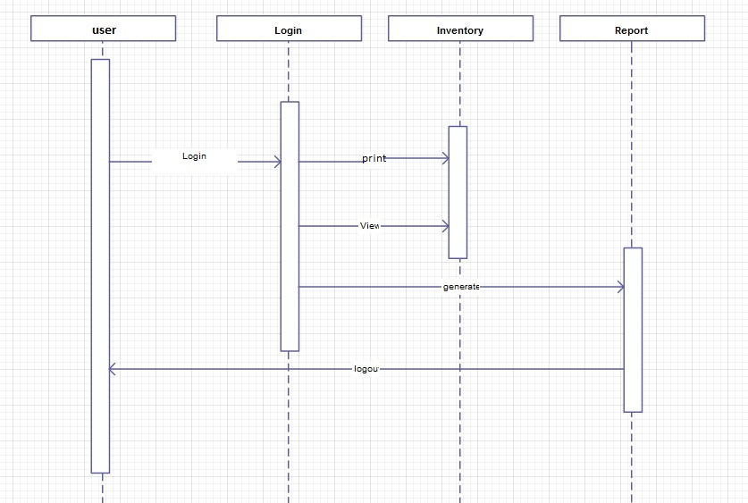

## **Activity Diagram**

**Admin**:

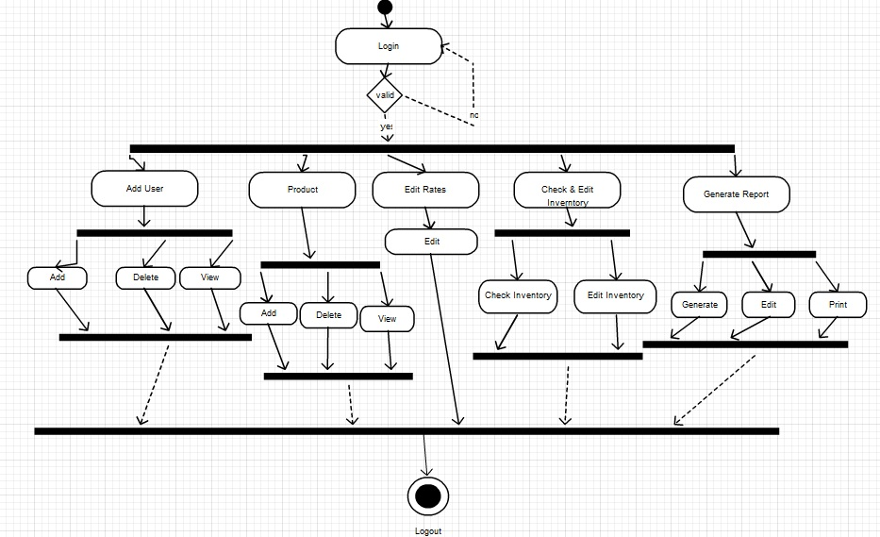

**Client:**

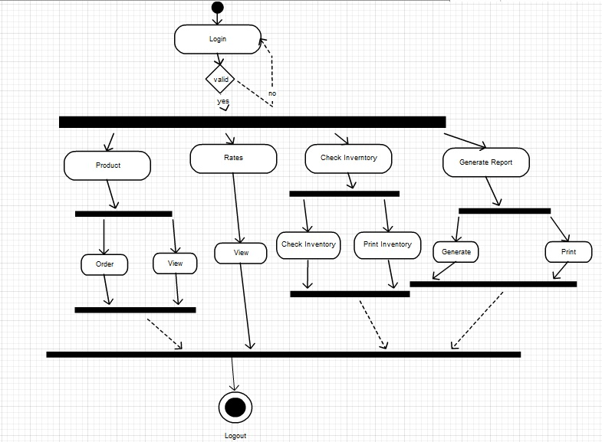

# **Class Diagram**

## Overview of Class Structure

The class diagram for the Inventory Management System (IMS) provides a visual representation of the system's architecture, showcasing the various classes that comprise the application. Key classes include:

* **Product**: Represents the items managed within the inventory. Attributes include **ProductID**, **Name**, **SKU**, **Barcode**, **Category**, **Quantity**, **UnitPrice**, **CreatedAt**, and **UpdatedAt**. This class encapsulates all relevant information about a product and methods for managing product data.
* **Order**: A base class for both **PurchaseOrder** and **SalesOrder**, containing common attributes such as **OrderID**, **OrderDate**, **Status**, and **TotalAmount**. This class serves as a foundation for order management, allowing for shared functionality between different types of orders.
* \*\*User \*\*: Represents the individuals who interact with the IMS. Attributes include **User ID**, **User Name**, **PasswordHash**, **Role**, and **CreatedAt**. This class manages user authentication and authorization, ensuring secure access to the system.
* **Report**: Represents various reports generated by the system, such as inventory valuation and sales trends. Attributes include **ReportType**, **DateGenerated**, and **Status**. This class is responsible for encapsulating the logic related to report generation and data retrieval.
* **AuditLog**: Captures actions performed by users within the system, including **LogID**, **User ID**, **Action**, **TableAffected**, **ActionTime**, and **Description**. This class is crucial for maintaining accountability and tracking changes made in the system.
* **Notification**: Represents alerts and messages generated by the system, with attributes such as **Type**, **Message**, and **Timestamp**. This class is used to inform users of important events, such as low stock levels or system updates.

## Class Relationships

The relationships between classes in the IMS are depicted in the class diagram, illustrating how different components interact within the system:

* **Associations**:
  + The **Product** class has a one-to-many relationship with the **Order** class, indicating that multiple orders can include the same product.
  + The **User** class has a one-to-many relationship with the **AuditLog** class, as each user can generate multiple audit logs.
* **Dependencies**:
  + The **Report** class depends on the **Product** and **Order** classes to generate reports based on inventory and sales data.
  + The **Notification** class may depend on the **User** class to send alerts to specific users based on their roles and actions.

## Associations and Inheritance

The class diagram highlights both associations and inheritance relationships:

* **Inheritance**:
  + The **Order** class serves as a base class for **PurchaseOrder** and **SalesOrder**, allowing for shared attributes and methods while enabling specific implementations for each order type. This promotes code reusability and simplifies maintenance.
* **Associations**:
  + The diagram illustrates how classes are interconnected, such as the relationship between **Product** and **PurchaseOrder**, where a purchase order can reference multiple products, and each product can appear in multiple purchase orders.

# Implementation

## Development Process

The development process for the IMS followed an agile methodology, which emphasizes flexibility and iterative progress. Key phases included:

* **Requirements Gathering**: Engaging with stakeholders to identify their needs and expectations for the IMS. This phase involved collecting feedback on desired features and functionalities.
* **Design**: Creating architectural diagrams, including class diagrams and flowcharts, to outline the system's structure and interactions. This phase also included designing the user interface to ensure a user-friendly experience.
* **Implementation**: Writing the code for the IMS using C# and WPF. The implementation phase involved developing core functionalities, such as inventory tracking, order management, and user authentication.
* **Testing**: Conducting unit tests, integration tests, and user acceptance tests to ensure the system functions as intended. This phase involved identifying and fixing bugs, as well as validating that the system meets user requirements.
* **Deployment**: Releasing the IMS to users, accompanied by training sessions and documentation to facilitate smooth adoption.

# Screenshots of all User Interfaces

Screenshots of the user interfaces demonstrate the system's functionality and user experience. Key interfaces include:

* **Register Page:**

This interface allows new users to create an account by entering their personal information, including username, password ensuring secure access to the IMS.

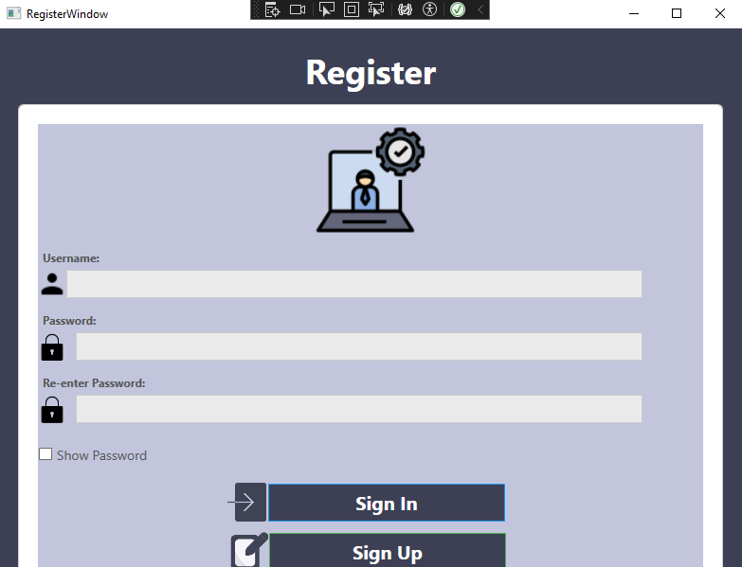

* **Login Page**: This interface enables users to securely access the Inventory Management System by entering their username and password, ensuring that only authorized personnel can log in and manage inventory operations.

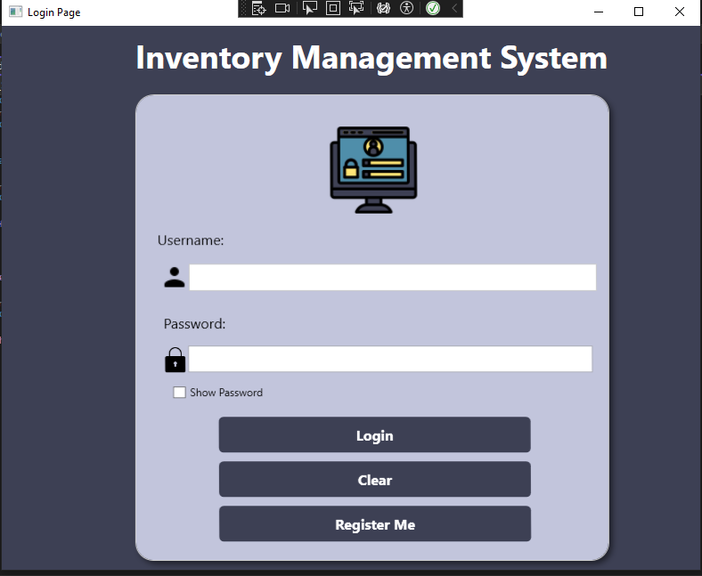

* **Dashboard**: Provides an overview of inventory levels, recent activities, and alerts.

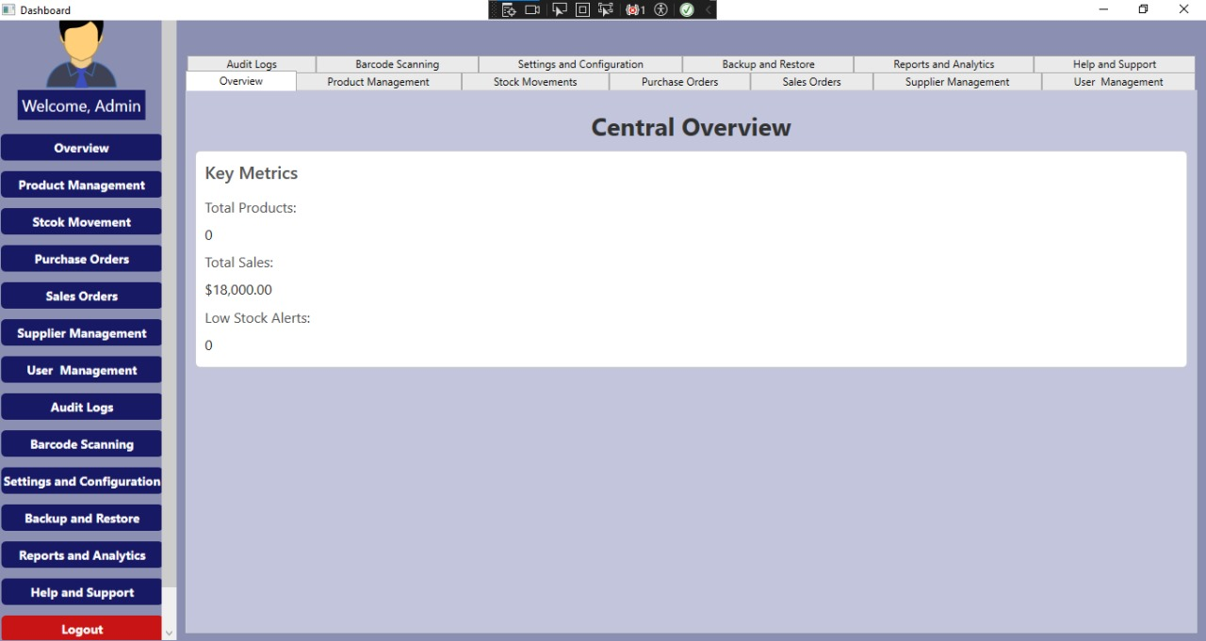

* **Product Management**: Allows users to add, edit, and delete product information.

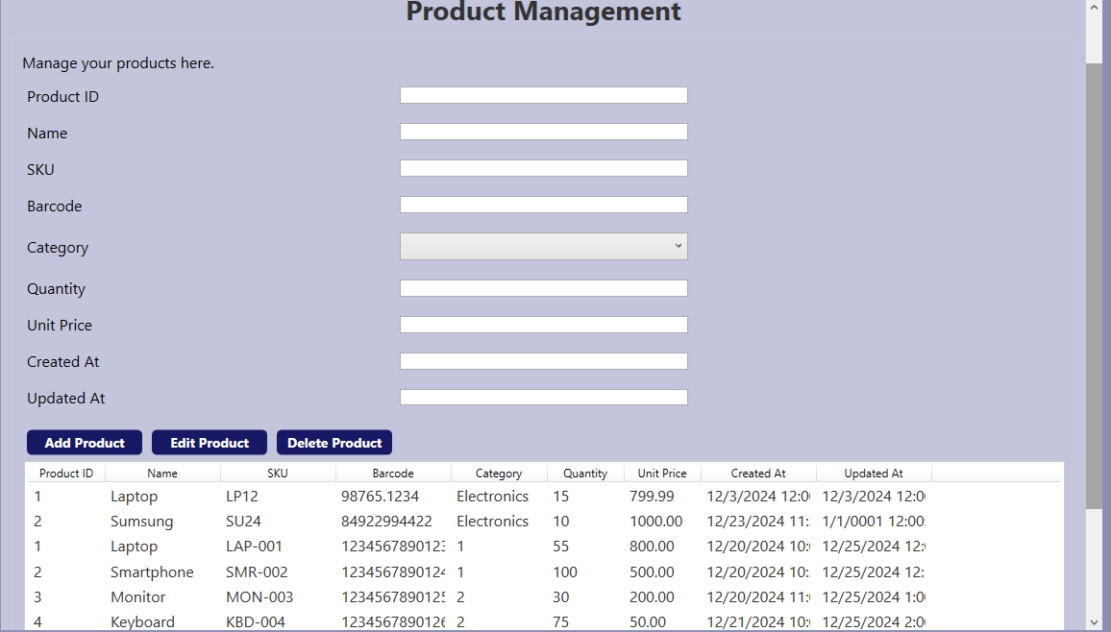

* **Order Management**: Facilitates the creation and management of purchase and sales orders.

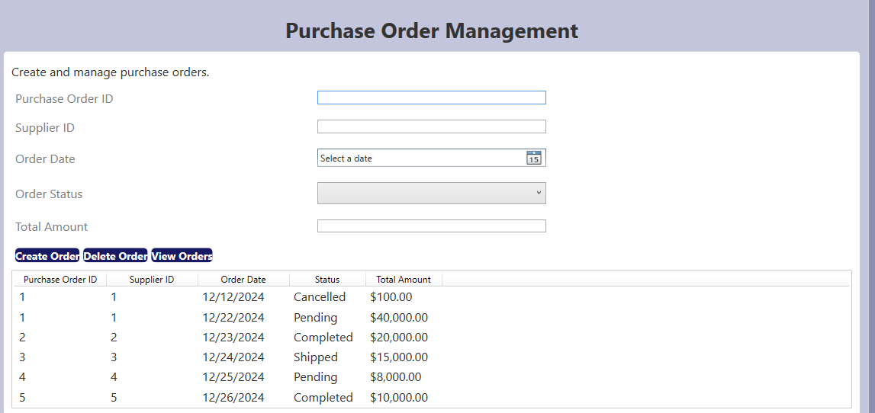

* **Product Management Page**: This interface allows users to efficiently manage product information, including adding new products, editing existing details, and deleting products, ensuring that the inventory remains accurate and up-to-date.



* **Reports and Analytics**: Displays generated reports and visual analytics for inventory and sales performance.

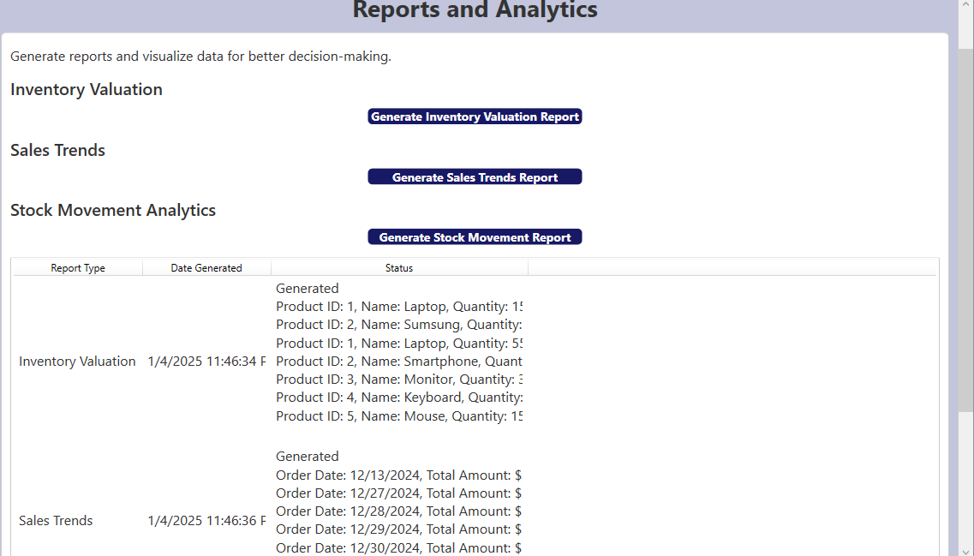

* **Audit Log**: This interface provides a detailed log of all actions performed by users within the IMS, enhancing accountability and traceability.

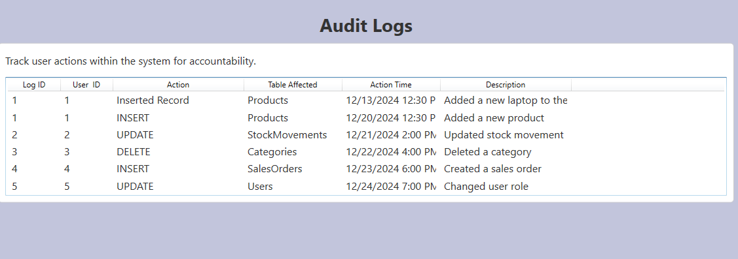

* **Supplier Management:** This interface enables users to manage supplier information, ensuring that all supplier details are up-to-date.

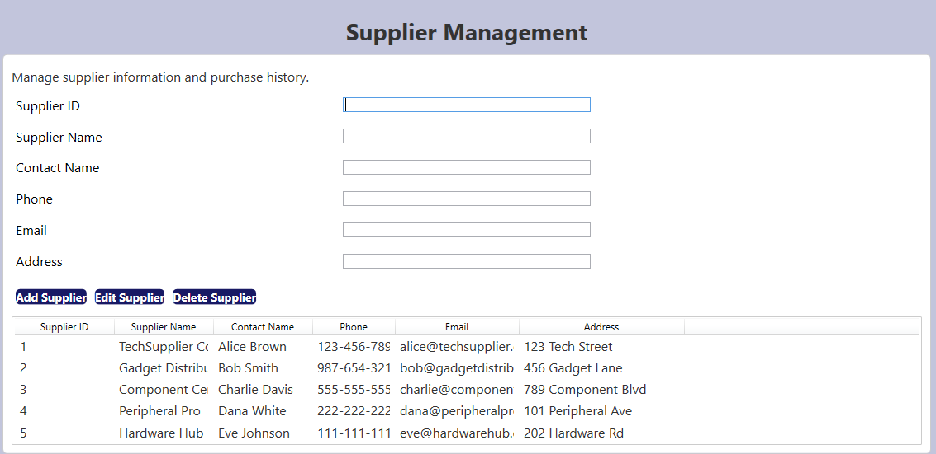

* **Stock Movement Page**: This interface provides a detailed view of all stock transactions, including inflows, outflows, and adjustments, allowing users to track inventory changes over time effectively.

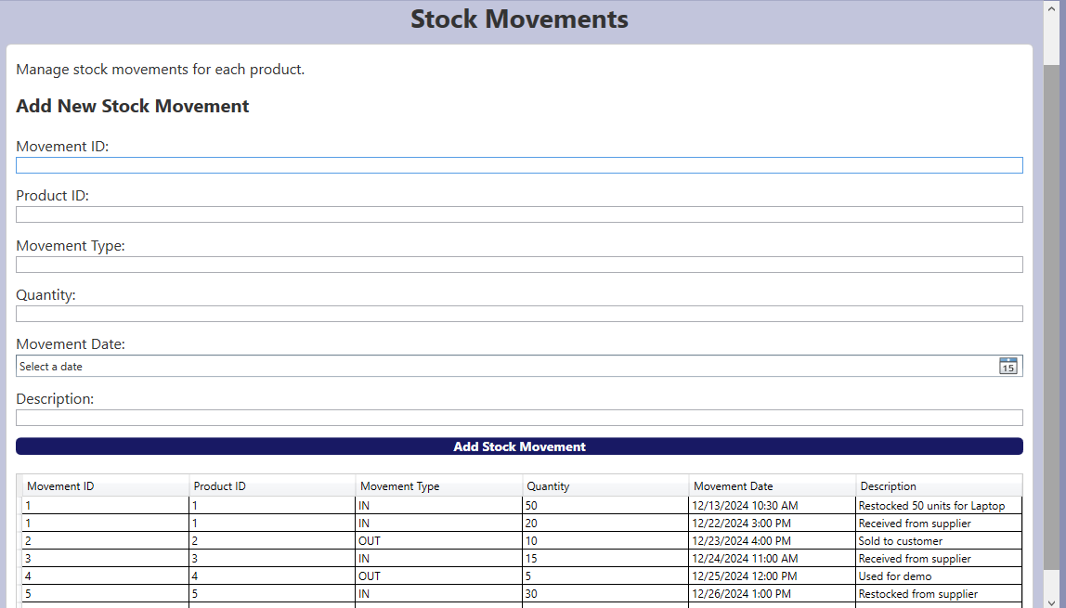

* **Supplier Management Page**: This interface enables users to efficiently manage supplier information, including adding, editing, and deleting supplier details, ensuring that all supplier records are up-to-date and accessible



* **Settings and Configuration Page**: This interface allows users to customize system preferences, manage integration settings, and configure application parameters to optimize the Inventory Management System for their specific operational needs.

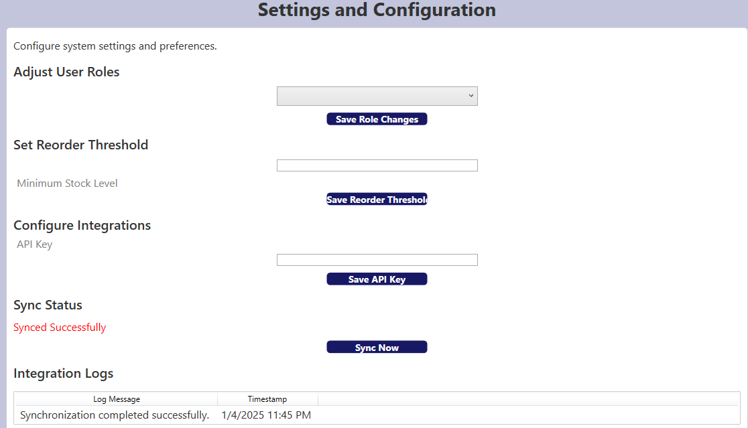

* **User Management Page**: This interface allows administrators to manage user accounts, including adding, editing, and removing users, as well as assigning roles and permissions to ensure secure access to the Inventory Management System.

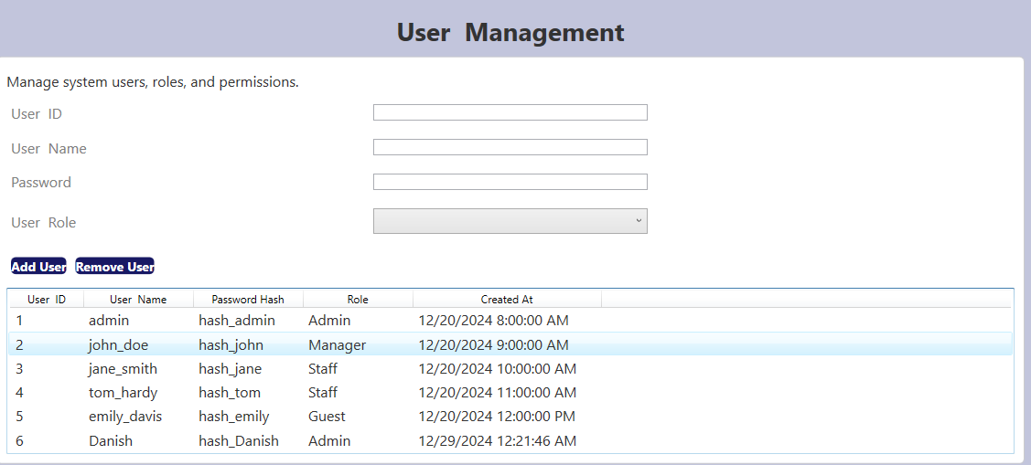

* **Backup and Restore Page**: This interface provides users with the functionality to create backups of the system's data and restore it from previous backups, ensuring data integrity and security in case of data loss or system failure.

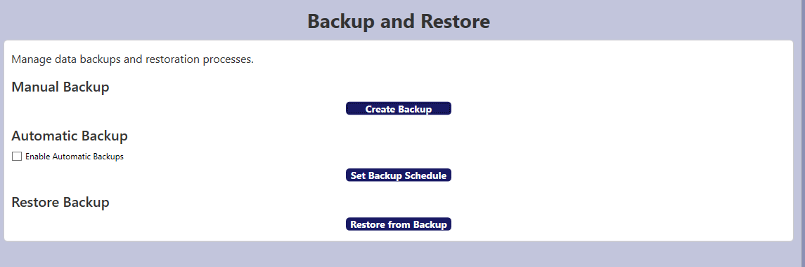

* **Barcode Scanning Page**: This interface enables users to quickly scan product barcodes for efficient inventory tracking and management, allowing for instant retrieval of product information and streamlined stock updates.

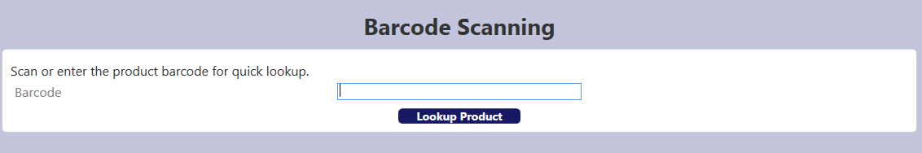

* **Help and Support Page**: This interface provides users with access to resources such as FAQs, user manuals, and contact information for technical support, ensuring that assistance is readily available for any issues or questions related to the Inventory Management System.

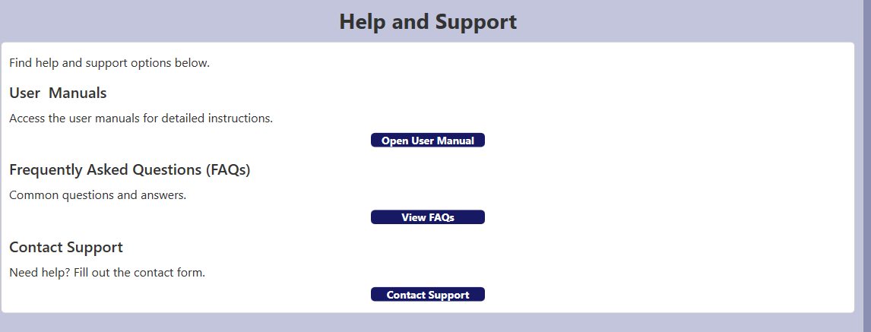

* **Central Overview Page**: This interface offers a comprehensive snapshot of key metrics and performance indicators related to inventory, orders, and user activities, allowing users to quickly assess the overall health of the Inventory Management System at a glance.

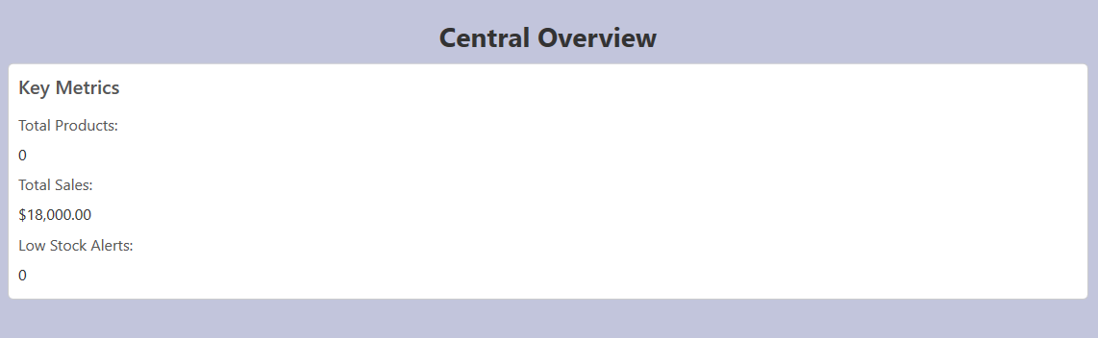

## Tools and Technologies Used

The IMS was developed using a combination of technologies, including:

* **Programming Language**: C# for backend development, leveraging its object-oriented features to create a robust and maintainable codebase.
* **Framework**: WPF (Windows Presentation Foundation) for building the user interface, allowing for rich desktop applications with a modern look and feel.
* **Database**: SQL Server for data storage and management, providing a reliable and scalable solution for handling inventory and order data.
* **Version Control**: Git for source code management, enabling collaborative development and version tracking throughout the project lifecycle.
* **Testing Framework**: NUnit for unit testing, ensuring that individual components function correctly and meet specified requirements.

## Challenges and Solutions

Throughout the development process, several challenges were encountered, including:

* **Data Synchronization**: Ensuring real-time updates across multiple locations was addressed by implementing efficient database triggers and background services. This solution allowed for immediate reflection of changes in inventory levels and order statuses, enhancing the system's reliability.
* **User Authentication**: Implementing secure user authentication was achieved through role-based access control and password hashing techniques. This approach ensured that sensitive data remained protected and that users could only access functionalities relevant to their roles.
* **Performance Optimization**: As the volume of data grew, performance issues arose during report generation. To address this, indexing strategies were implemented in the SQL Server database, significantly improving query performance and reducing load times for users.
* **User Feedback Integration**: During testing, users provided feedback regarding the interface's usability. This feedback was incorporated into the design, leading to enhancements in navigation and overall user experience.

# Enhanced Theme and User Interface Design

The Inventory Management System (IMS) incorporates a visually appealing and user-friendly design to improve the user experience. The system is designed with a **dark blue theme**, offering a modern and professional appearance that reduces eye strain and enhances usability during prolonged usage.

Login-and-Registration-Features  
The IMS includes dedicated features for **user login** and **registration (sign up)** to ensure secure and personalized access. The login interface enables registered users to authenticate themselves with their credentials, while new users can seamlessly register through the sign-up functionality. This dual feature enhances user management and ensures that only authorized personnel access the system.

Scroll-Bar-Integration  
To facilitate smooth navigation and data handling, the IMS integrates **scroll bars** in critical areas:

## Dashboard:

* + A scroll bar is automatically enabled whenever the number of displayed entries exceeds the visible area. This ensures that users can effortlessly browse through extensive datasets without compromising the layout.

## Grid View:

* + In grid views, such as inventory lists and order histories, the scroll bar dynamically appears for seamless data exploration, even when records grow significantly.

## Side Panel:

* + The side panel incorporates a vertical scroll bar for easy navigation through menus and features, especially in cases where additional options are introduced over time.

Icon-Integration  
The IMS interface is further enhanced with **icons** strategically placed in menus, buttons, and navigation panels. These icons serve as intuitive visual cues, improving usability and providing a polished aesthetic. Icons contribute to an organized and accessible user interface while aligning with the system's modern theme.

Explanation  
The IMS prioritizes both functionality and design excellence. By integrating a visually appealing dark blue theme, robust login and registration mechanisms, and intuitive scroll bar functionality across key components, the system ensures a seamless and professional experience for users. The addition of icons further elevates the aesthetic quality, making the IMS a comprehensive solution for inventory management.

# **Conclusion**

The Inventory Management System (IMS) is a comprehensive and robust platform tailored to address the complexities of modern inventory management. By integrating essential features such as **real-time stock tracking**, **multi-location support**, and **detailed order management**, the IMS ensures that businesses can monitor and manage their inventory efficiently, regardless of scale or complexity. The system's ability to provide **comprehensive reporting and analytics** further empowers businesses to make informed decisions based on historical trends and real-time data, optimizing operational efficiency and reducing waste. The secure and thoughtfully designed database ensures **data integrity, accuracy, and compliance** with industry standards, making it a reliable backbone for storing sensitive information such as stock movements, product details, and user activity logs. With role-based access control, the IMS upholds a secure environment, ensuring that sensitive operations are performed only by authorized users, thereby mitigating the risk of errors or unauthorized changes. Moreover, the IMS is designed with scalability in mind, allowing for seamless integration with external platforms such as **e-commerce systems, accounting software, and notification services**. This extensibility ensures that the system can evolve alongside the growing needs of the business, offering a future-proof solution for inventory management. The objectives set forth at the beginning of the project have largely been met, with the system providing real-time inventory updates, comprehensive reporting, and enhanced user management capabilities. **Future enhancements** for the IMS may include:

* Integration of machine learning algorithms for predictive analytics.
* Expansion of mobile access for on-the-go inventory management.
* Enhanced reporting features with customizable dashboards for users.

# References

## Books

* Programming in C# a primer

By: E Balagurusamy

Publication: Tata McGraw Hill

* Software Engineering

By: Sommerville

Publication: Low Price Edition

## Web References

* www.code.project.com
* www.google.com
* www.asp.net.com
* [www.wikipedia.org](http://www.wikipedia.org)